Obstacles

Obstacles
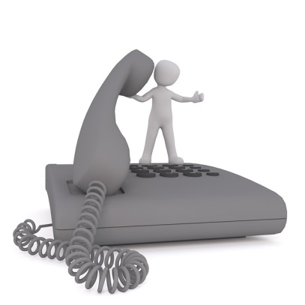
What problems can occur if people want to have a conversation together?

Can you name something that hinders you from talking?

What can you change?

Some things are disturbing in a conversation. They are killing the conversation. Shouting is an example of this.

What annoys you during a conversation?

Words :

Things people do:

