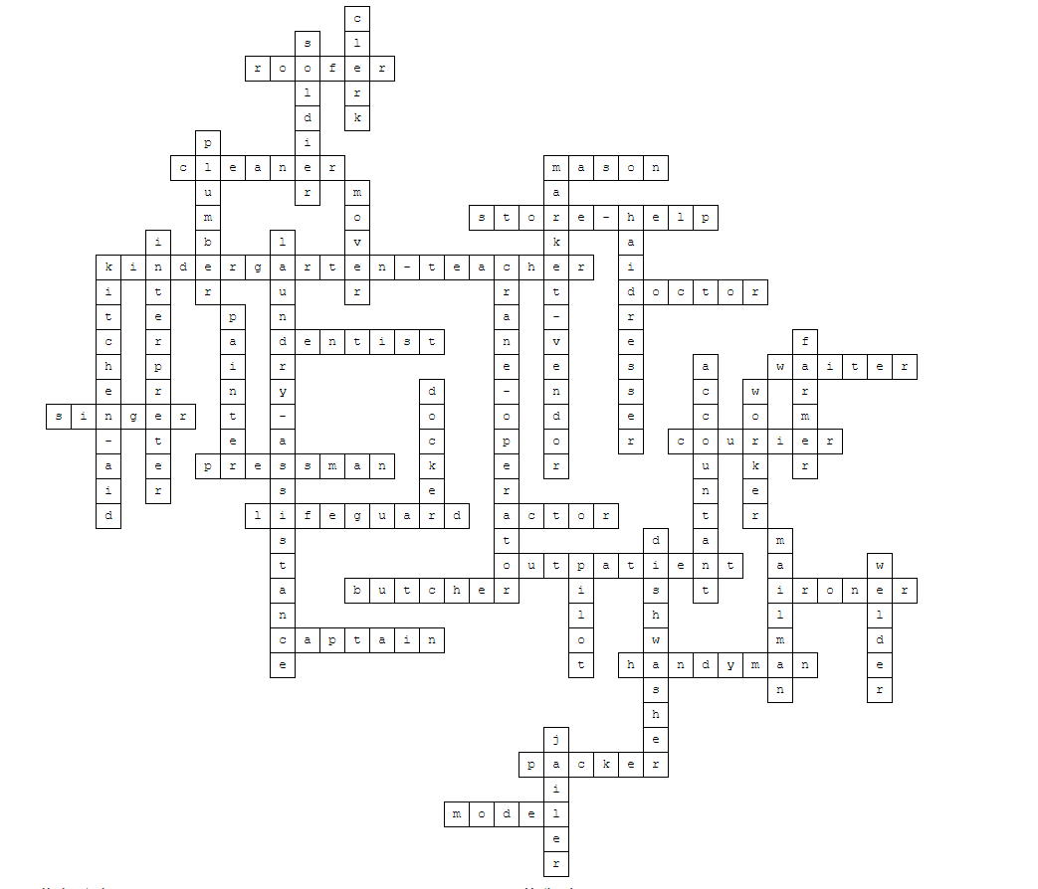
painter Paint is your biggest friend
outpatient You transport sick people
handyman You fix something when it's broke
doctor You help sick people
captain You certainly can't get seasick
plumber The pipes of the toilet are blocked
farmer I have a lot of cows
pressman I make sure all the words in books are printed
market vendor I move my shop every day
accountant You have to be good with numbers and money
kindergarten-teacher I like working with little kids
mason Making a wall is easy for you
clerk You work at a desk, often with a computer
store help You're there to help in a store
docker Large boats full of goods is your workplace
dishwasher This plate is dirty, how are we going to fix this
packer You like putting stuff neatly in boxes
pilot You go 800 km/h sometimes, with your head in the clouds
kitchen aid Who makes dessert for me?
lifeguard Blub, blub, I see someone drowning
laundry assistance I'll clean your clothes
interpreter I speak different languages so you can understand what someone else says in a different laguage
cleaner I like when everything is clean
courier Did you order a package?
roofer Oops, that roof tile is crooked
ironer I'll take the wrinkles out of your clothes
singer I have a nice voice and perform on stage
worker I mainly do manual labour
dentist Auw, my tooth hurts, I have to go to...
jailer I guard people who were punished
welder I can attach iron and other metals to each other and they're not getting loose (without glue or screws)
mailman I'll make sure your paper is in your mailbox every day
crane operator I don't have fear of heights and help build houses
mover If you have a new house, you need me to bring your stuff to your new house
soldier I have a gun and guard the country
waiter I bring you a drink on the terrace
butcher You can buy a nice piece of meat here
actor I play a part in a tv show
haidresser Your hair is nice, thanks to me
model I walk on a stage and people look at the nice clothes I'm wearing

